Henry VIII’s Wives – Record Sheet
WIFE 1 – CATHERINE OF ARAGON
________________________________________________________________________________________________________________________________________________________________________________________________________________________________________________________________________________________________________________________________
________________________________________________________________________________________________________________________________________________________________________________________________________________________________________________________________________________________________________________________________________________
________________________________________________________________________________________________________________________________________________________________________________________________________________________________________________________________________________________________________________________________________________

WIFE 2 – ANNE BOLEYN
________________________________________________________________________________________________________________________________________________________________________________________________________________________________________________________________________________________________________________________________
________________________________________________________________________________________________________________________________________________________________________________________________________________________________________________________________________________________________________________________________________________

WIFE 3 – JAYNE SEYMOUR
________________________________________________________________________________________________________________________________________________________________________________________________________________________________________________________________________________________________________________________________
________________________________________________________________________________________________________________________________________________________________________________________________________________________________________________________________________________________________________________________________________________

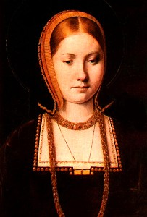
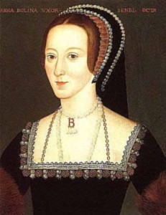
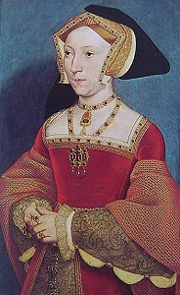
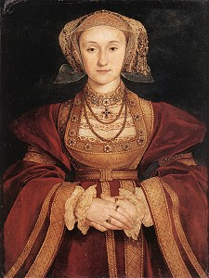
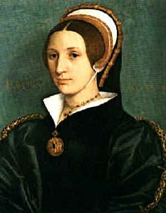
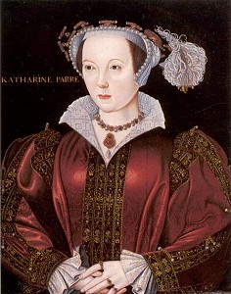
WIFE 4 – ANNE OF CLEVES
________________________________________________________________________________________________________________________________________________________________________________________________________________________________________________________________________________________________________________________________
________________________________________________________________________________________________________________________________________________________________________________________________________________________________________________________________________________________________________________________________________________

WIFE 5 – CATHERINE HOWARD
________________________________________________________________________________________________________________________________________________________________________________________________________________________________________________________________________________________________________________________________
________________________________________________________________________________________________________________________________________________________________________________________________________________________________________________________________________________________________________________________________________________

WIFE 6 – KATHERINE PARR
________________________________________________________________________________________________________________________________________________________________________________________________________________________________________________________________________________________________________________________________
________________________________________________________________________________________________________________________________________________________________________________________________________________________________________________________________________________________________________________________________________________

