WIFE 1 – CATHERINE OF ARAGON

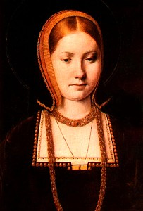

Born: 16 October,1485 at Alcala de Henares, Spain.
Nationality: Spanish
Married Henry: 11 June, 1509 at Greenwich Palace, Kent.
Divorced: 23 May, 1533
Died: 7 January, 1536
Buried: Peterborough Cathedral.

Catherine of Aragon was a Spanish princess who had previously been married to Henry's brother Prince Arthur. Henry was betrothed to Katherine by his father in 1509 and they had a daughter Mary who later become Queen Mary 1. Catherine had six children but only Mary survived. In 1527 Henry announced his desire to divorce Catherine because she had failed to produce a male heir.
WIFE 2 – ANNE BOLEYN

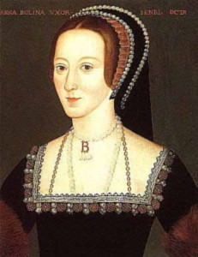

Born: circa 1500-1502 at Blickling Hall in Norfolk.
Nationality: English
Married Henry: 25 January,1533, at York Palace, London.
Divorced: 17 May, 1536
Died: 19 May, 1536, executed for high treason, Tower of London.
Buried: Chapel of St. Peter ad Vincula, Tower of London.

Anne grew up in the family home of Hever Castle in Kent and was a young and beautiful lady-in-waiting to the former queen, Catherine of Aragon. She gave birth to the future Queen Elizabeth. When Anne miscarried a second child Henry accused her of witchcraft and had her beheaded on May 19th 1536 at the Tower of London for adultery and incest.
WIFE 3 – JAYNE SEYMOUR

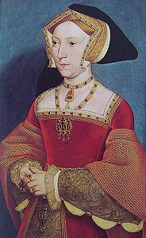

Born: circa 1507-1509, Wiltshire.
Nationality: English
Married Henry: 30 May, 1536 at Whitehall Palace, London.
Died: 24 October, 1537
Buried: St. George's Chapel, Windsor Castle.

Jane was born between 1507 and 1509. Henry married his third wife on May 30th, 1536, just eleven days after the execution of Anne. Jane gave birth to a baby boy on 12th October 1537. Henry was said to be devastated when she died 12 days later of blood poisoning. Jane was buried at Windsor Castle, later to be joined by Henry. Her son succeed Henry to become Edward VI.
WIFE 4 – ANNE OF CLEVES

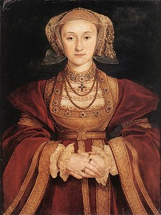

Born: 22 September, 1515 at Dusseldorf, Cleves, Germany.
Nationality: German
Married Henry: 6 January, 1540 at Greenwich Palace, London.
Divorced: 9 July, 1540
Died: 16 July,1557 at Chelsea Old Palace, London
Buried: Westminster Abbey.

Anne was born in 1515 in the small north German state of Cleves (close to the border of Holland). Her parents were John III of Cleves and Marie of Julich. Anne married Henry in 1540 to form a tie between England and the Protestant princes of Germany. After only six months Henry found the political alliance no longer to be to his advantage and so divorced her the same year. She died in 1557.
WIFE 5 – CATHERINE HOWARD

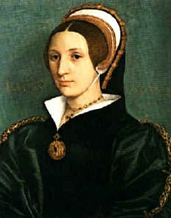
Born: circa 1525 at Lambeth, London or Horsham, Sussex
Nationality: English
Married Henry: 28 July, 1540 at Oatlands Palace, London.
Died: 13 February 1542 executed for high treason Tower of London.
Buried: Chapel of St. Peter ad Vincula, Tower of London

Catherine was born between 1520 and 1525. Henry married Catherine Howard, Anne Boleyn's cousin and maid of honour to Anne of Cleaves. In 1542 Henry once again accused his wife of adultery and had Catherine beheaded at the Tower of London on 13 February 1542.
WIFE 6 – KATHERINE PARR

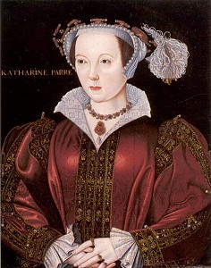

Born: circa 1512, at Kendal Castle, Cumbria or Blackfriars, London.
Nationality: English
Married Henry: 12 July, 1543 at Hampton Court Palace.
Died: 7 September, 1548
Buried: Sudeley Castle, Gloucestershire.

Katherine Parr, also known as Catherin Parr, was born around 1512. She was Henry VIII’s sixth and final wife. She married Henry VIII on 12 July 1543 at Hampton Court Palace. Katherine outlived Henry - so she is said to have survived.

