Classics: Suggested Reading List Years 5 and 6

Here is a suggested reading list to help you find new books to read. Remember, if you find a book you enjoy, try another one from the list or try to find another book by the same author.

The school library might not have all the titles on the list; however, you should be able to find them in the local library.

If you would like to recommend a book for this list, give the details to your Reading Ambassador.

Cover | Synopsis | Title and Author
 | This Ladybird Classic is an abridged retelling of the classic story | Gulliver’s Travels
 | of Gulliver's Travels by Jonathan Swift, making it perfect for | Jonathan Swift
 | introducing the story to younger children, or for newly confident | Jonathan Swift
 | readers to tackle alone.
 | Beautiful new illustrations throughout will bring the magic of
 | this classic story to a new generation of children.
 | The quintessential American writer, Washington Irving emerged | The Legend of
 | as the country's first popular author with such beloved | Sleepy Hollow and
 | nineteenth-century short stories as "The Legend of Sleepy | Other Stories
 | Hollow" and "Rip Van Winkle." These highly entertaining fiction | Washington Irving
 | masterpieces reveal Irving's unique mastery at portraying the | Washington Irving
 | landscapes and culture of early America.
 | This modestly priced edition includes both of these Irving
 | landmarks, as well as other acclaimed short works by the
 | famous essayist, travel writer, biographer, and historian:
 | * The Spectre Bridegroom
 | * The Devil and Tom Walker
 | * The Wife
 | * Westminster Abbey
 | * Mountjoy
 | * Adventure of the Mysterious Stranger and five other classics.
 | Filled with satire, pathos, and picturesque observations, these
 | remarkable stories are important foundations of the American
 | literary tradition.
 | Twenty tales collected from German folklore and immortalized | Grimm’s Fairy
 | by the brothers Grimm. | Tales
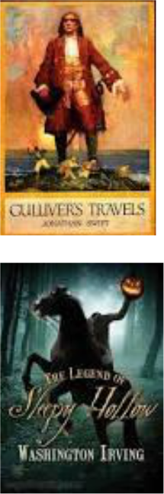
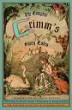
Classics: Suggested Reading List Years 5 and 6

 | The classic Dickensian tale of a little boy who wanted more, | Oliver Twist
 | beautifully repackaged for a new generation by Simon & | Charles Dickens
 | Schuster Classics. | Charles Dickens
 | Oliver Twist is orphaned and on the streets of London. Alone
 | and vulnerable, he forms a new kind of family with a group of
 | pickpockets, led by the enigmatic Fagin.
 | At first Oliver's new family provides a sense of hope, but it is not
 | long before the true colours of London's underclass reveals
 | itself: prostitution, scheming, desperation and greed surround
 | Oliver, making his prospects of happiness seem bleak. But this
 | young boy, who never seems to stop running, is nothing like
 | those he runs from.
 | Oliver Twist is a mesmerising story of childhood and, ultimately,
 | of success against the odds.
 | One of the preeminent novels by French writer Alexandre | The Three
 | Dumas, this swashbuckling tale follows a group of honorable | Musketeers
 | 17th-century swordsmen who must contend with powerful | Alexandre Dumas
 | adversaries scheming against the queen. Determined to join the | Alexandre Dumas
 | royal guard, young d'Artagnan leaves his country home and
 | travels to Paris, where he unintentionally angers Aramis, Athos,
 | and Porthos, the esteemed Three Musketeers. Eventually
 | winning the trust and admiration of the formidable trio of
 | fighters, d'Artagnan joins them in their quest to thwart the plans
 | of the sinister Cardinal Richelieu.
 | Jules Verne's classic science fiction tale sends Professor Von | A Journey to the
 | Hardwigg, his nephew Axel, and their guide Hans through a | Centre of the
 | crater in Iceland and into the earth. As the group explores what | Earth
 | is below the outer crust, they encounter many strange and | Jules Verne
 | wonderful sights. Their travels from Iceland to Italy uncover a | Jules Verne
 | lost world, amazing creatures, and dangerous adventures below
 | us
 | Treasure Island, published in 1883, popularized the now familiar | Treasure Island
 | characters of pirates and brought them to rum-swilling life. | Robert Louis
 | When an old sailor named Billy Bones dies in the inn belonging | Robert Louis
 |  | Stevenson
 | to young Jim Hawkins’s parents, he leaves a greasy old map on | Stevenson
 | which an “X” marks the spot where treasure is buried. Jim joins
 | the crew of a ship in pursuit of Bones’s treasure, and on the seas
 | meets up with Long John Silver, a peg-legged pirate who has
 | infiltrated their ranks. Jim must survive mutinies and counter-
 | mutinies, face hand-to-hand combat with drunken sailors, and
 | outwit double-crossing thieves before the treasure can be his.
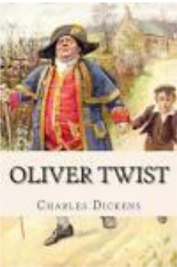
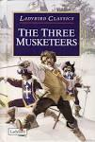
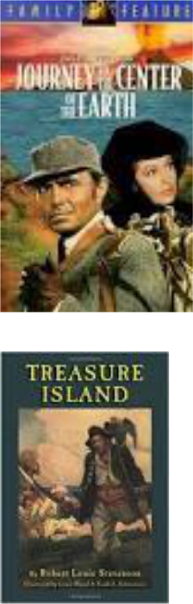
Classics: Suggested Reading List Years 5 and 6

 | Rudyard Kipling's classic collection presents the tales of the | The Jungle Book
 | Jungle. When Shere Khan misses killing the man's cub, Father | Rudyard Kipling
 | Wolf brings him into his pack. Mother Wolf quickly names him | Rudyard Kipling
 | Mowgli the Frog and a new cub joins the pack. Learn the Law of
 | the Jungle from old Baloo and Bagheera along with Mowgli in
 | the Calico Illustrated Classics adaptation of Kipling's The Jungle
 | Book.
 | White Fang, written by Jack London, is the mirror work of the | White Fang
 | author’s famous novel The Call of the Wild. Much of the story is | Jack London
 | written from the view point of the animal, and how he judges | Jack London
 | the world around him and adjusts accordingly. This book depicts
 | the birth and life of White Fang, a three quarters wolf-dog
 | hybrid. When famine sets in, a pack of wolves start pursuing two
 | men in the northern wilderness. Later, with the ease of food, the
 | leader of the pack – a she-wolf dog – gives birth to a litter of
 | pups of which only one survives, to lead an unpredictable and
 | dangerous life.
