Here is a suggested reading list to help you find new books to read. Remember, if you find a book you enjoy, try another one from the list or try to find another book by the same author.
The school library might not have all the titles on the list; however, you should be able to find them in the local library.
If you would like to recommend a book for this list, give the details to your Reading Ambassador.
Cover | Synopsis | Title and Author
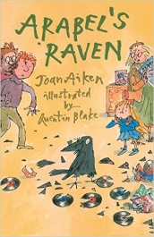 | Mr Jones, while driving his taxi, notices something bedraggled in the road. He stops and discovers an injured Raven which he takes home and Arabel falls in love at first sight. 'His name is Mortimer,' she announces and Mortimer has found a home. A series of thefts and a robber quarrel are only two of the dramas in this story. elightful tale. | Arabel’s Raven  Joan Aiken
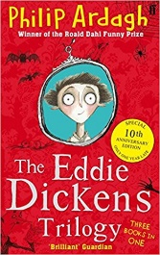 | First, both of Eddie's parents catch a disease that makes them turn yellow and he must stay at their house Awful End. Eddie then avoids an explosion and arrest, and then falls into the hands of a gang of escaped convicts who have 'a job for him to do'. Finally, Eddie must travel to America but he has a stowaway in his case... | The Eddie Dickens Trilogy  Philip Ardagh
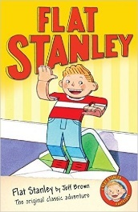 | Stanley Lambchop is an ordinary boy with a big problem. One night, a giant pinboard falls on top of him leaving him completely flat. At first, Stanley enjoys the benefits of his new shape - it can be fun going in out of rooms simply by sliding under the door. And it's a hoot being posted to your friends in California for a holiday. not always easy being different, and, once the novelty begins to wear off. | Flat Stanley  Jeff Brown
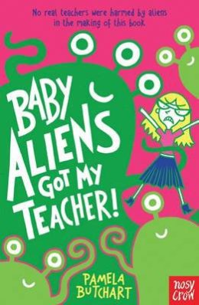 | Izzy’s teacher, Miss Jones, suddenly starts being nice to them. Instead of shouting and making them do maths, she gives them sweets, lets them watch films, and seems strangely happy. What is going on? Has she been taken over by aliens, and has an evil plan to make them all into aliens too. | Baby Aliens Got My Teacher!  Pamela Butchart
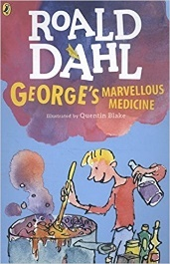 | One Saturday morning, George is in charge of giving Grandma her medicine. So-ho! Ah-ha! Ho-hum! George knows exactly what to do. A magic medicine it will be. One that will either cure her completely . . . or blow off the top of her head. | George's Marvellous Medicine  Roald Dahl
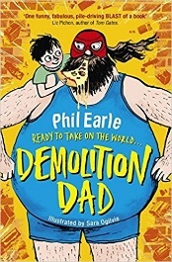 | George, Jake Biggs' dad, spends all week knocking down buildings and all weekend knocking down wrestlers. He's the Demolition Man, and Jake couldn't be prouder. But when Jake hears about a pro-wrestling competition in the USA, and persuades his beloved dad to apply, things don't quite turn out the way he expected... | Demolition Dad  Phil Earle
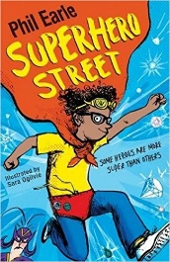 | Michael J Mouse doesn't get a lot of attention, what with his five brothers reducing mum and dad to exhausted, drooling zombie. But Mouse is also Mouse the Mighty, possibly the greatest superhero of all time. When a jewel heist goes wrong, he and his superhero mum Lady Lollipop prove it’s not just costumes that make people special. | Superhero Street  Phil and Ogilvie, Sara Earle
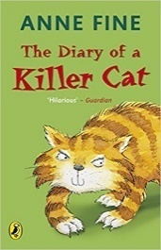 | Poor Ellie is horrified when Tuffy drags a dead bird into the house. Then a mouse. But Tuffy can't understand what all the fuss is about. Who on earth will be the next victim to arrive through the cat-flap? Can soft-hearted Ellie manage to get her beloved pet to change his wild, wild ways before he ends up in even deeper trouble? | The Diary of a Killer Cat  Anne Fine
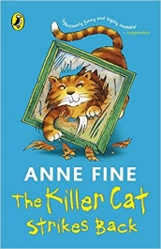 | Tuffy knows what he likes. And he doesn't like the 'art' that Ellie's mum brings home from her new classes. So, what's a cat to do? A few scratches here just happen to shred a painting. A nudge there somehow slips a vase off a shelf. Dad hope a horribly lumpy clay pot will be next, but Tuffy's having none of it. The killer cat will go his own way! | The Killer Cat Stikes Back  Anne Fine
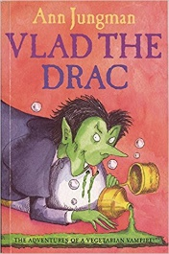 | During a holiday in Romania, Judy and Paul are very bored - that is until they meet a tiny vampire who is also a vegetarian with dreams of starring in horror films... The children smuggle Vlad back to London and decide to keep him a secret, however a vampire left on his own all day can get terribly bored and mischievous. | Vlad the Drac  Ann Jungman
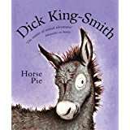 | Captain, Ladybird and Herbert - two Shire horses and a Suffolk Punch - are not pleased when Jenny, a retired seaside donkey, arrives at the Old Horses' Home. It's supposed to be a home for horses, and they don't want to share their field with a common little donkey. | Horse Pie  Smith Dick King
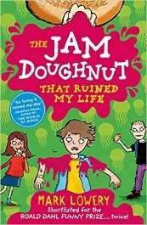 | Roman Garstang loves food - particularly Squidgy Splodge raspberry-jam doughnuts; because of his Monday-morning jam doughnut, Roman's week takes a very sticky turn… By Friday Roman has been banned from eating for 24hrs, narrowly avoided a faceful of warm toddler-wee and more hilarious adventures. | The Jam Doughnut that Ruined My Life  Mark Lowery
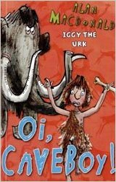 | The Urks are a warlike race with bushy beards and hairy legs. Urks like boulder-rolling and chasing lizards. They also like the Feast of Urks, when Urk boys must pass the Testing to become warriors. But Iggy isn’t quite like other Urks. He likes inventing things. Which is why he has been neglecting his axe-wielding practise… | Oi, Caveboy!  (Iggy the Urk series)  Alan Macdonald
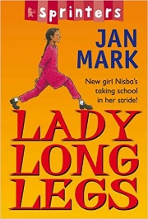 | Nisba may be new at Farm Lane School, but she won't be pushed about. When an older girl tries to stop Nisba from walking along the green tiles in the corridor, the new girl puts her foot down. She's got long legs and she's going to use them! | Lady Long Legs  Jan Mark
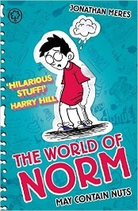 | Why on earth did Norm's family have to move, anyway? In their old house, he'd never tried to pee in anything other than a toilet. And when Norm is in bed, he's kept awake by his dad snoring like a constipated rhinoceros!  Will life ever get less unfair for Norm? | The World of Norm: May contain Nuts: Book 1  Jonathan Meres
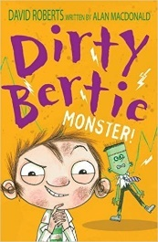 | Meet Dirty Bertie – a boy with nose-pickingly disgusting habits! He's full to bursting with madcap plans and crazy ideas, and if it's trouble you're after, look no further – Bertie's sure to be up to his neck in it! | Dirty Bertie Stories  David Roberts
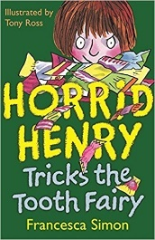 | Horrid Henry tries to trick the tooth fairy, has Moody Margaret to stay and sends her packing, makes teachers run screaming from school, and wrecks a wedding. | Horrid Henry Tricks the Tooth Fairy.  Francesca Simon
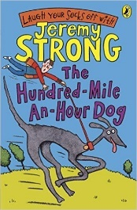 | Streaker is a mixed-up kind of dog...with quite a bit of Ferrari and a large chunk of whirlwind. Streaker is no ordinary dog. She's a rocket on four legs with a woof attached, and Trevor has got until the end of the holidays to train her. If he fails, he'll lose his bet with horrible Charlie Smugg, and something very, very yucky involving frogspawn will happen... | The Hundred Mile an Hour Dog  Jeremy Strong
 | Gary suspects he is turning invisible and blames the door-key he has to wear round his neck. Could it be a magic key? He decides to hide so that people will have to search and find him, thus proving that he isn't invisible after all. But first there are one or two problems in the way, such as a mysterious box of chocolates, a bloodstained body in an amusement arcade, a space-ship and an alien on the headland, all of which turn Gary's flight into a nightmare. | Invisible Boy  Hazel Townson
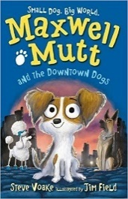 | Maxwell Mutt might be small, but his heart is big and the city is full of adventure and before long, he teams up with a gang of downtown dogs. When Maxwell hears the call of a friend in need, the dogs brave the big, bright city, where they hear tales of the Collector; the cruellest ever dog-catcher. But dreams, fun and adventure are waiting along the way... | Maxwell Mutt and the Downtown Dogs  Steve Voake
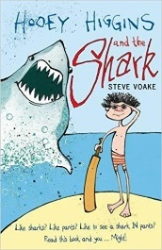 | Welcome to Shrimpton-on-Sea where the folks are unusual and you can make friends with Hooey, Twig, Will and Dingbat the dog. Are they naughty, slightly scruffy boys? Yes they are. Will they do anything for a few quid? Yes they will. What’s so unusual? Well, it starts with the giant chocolate egg, the shark in the flowery duvet – and more! | Hooey Higgins and the Shark  Steve Voake
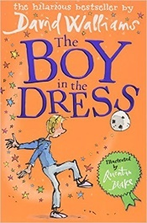 | 12-year-old Dennis lives unhappily after his mum leaves the family. A crack of light shines through as he strikes up a friendship with a girl based on their mutual love of Vogue magazine - and soon Dennis is trying out some of her dresses. | The Boy in the Dress  David Walliams

